**Linear Regression**

* Supervised Learning( training data and label are present)
* Regression indicates Predictive analysis
* Linear indicates linear relationship b/w features and target
* Linear regression is used widely in cases where we need to predict numerical values by using historical data as training data to train our model.
* We have features in X and target is Y.
* Aim of LR is to fit a best line to our data.
* Hypothesis equation

Image [7]

* Our target is to find optimum values of theta0 and theta1 such that for every value of x we calculate our predicted value.
* H(x) is nothing but the value we will predict. Theta0 is constant and theta1 is coefficient.
* Theta1 is basically slope of line. We also call it gradient.
* Regression coefficient (theta1) is defined as average change in dependent variable Y with 1 unit change in independent variable X.
* **Assumptions about Regression Line**
  + Our regression line is the line that minimizes the cost function or mean squared error function.
  + Theta0 is equal to intercept on Y axis.
  + Regression line passes through the mean of Y values and also through mean of X values.
  + Theta1 is average change in Y with one unit change in X.
* **The least square regression line is the only line that has all of these properties.**
* Cost function = mean of square of difference b/w predicted value and actual value

img12

* Will use Gradient Descent algorithm to find optimum values of parameters with minimum cost function.

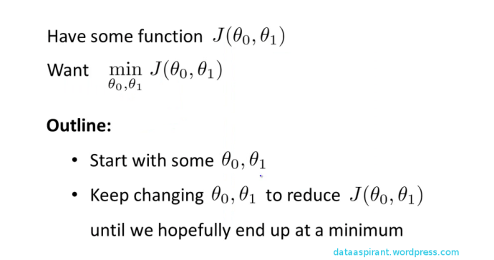

* **Summary** 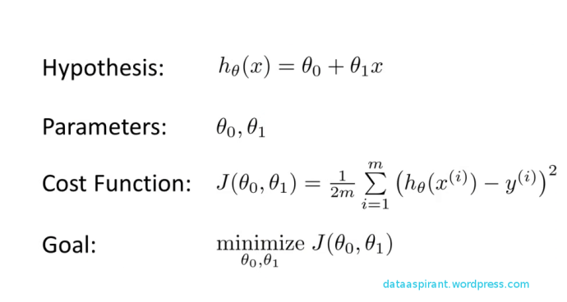



**Detail explanation of Gradient Descent**

**https://machinelearning-blog.com/2018/02/28/gradient-descent/**